State of art

- Global organization
- Mono-bloc
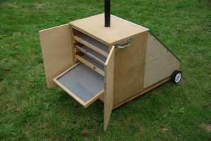

- Multi-bloc
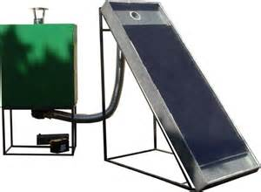

- Transportable
    - Fixe
    - Transportable
- Portable
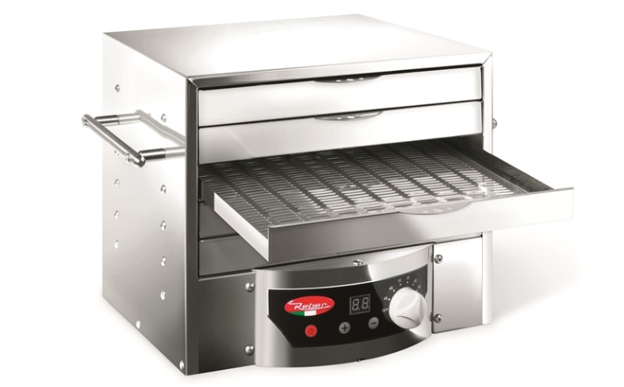

- Pliable
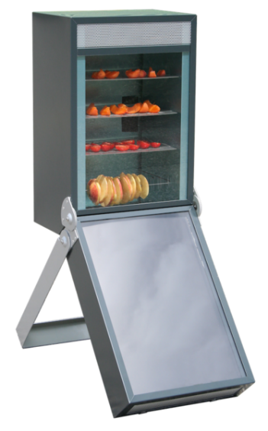
- wheel
- Drying room
- Building :
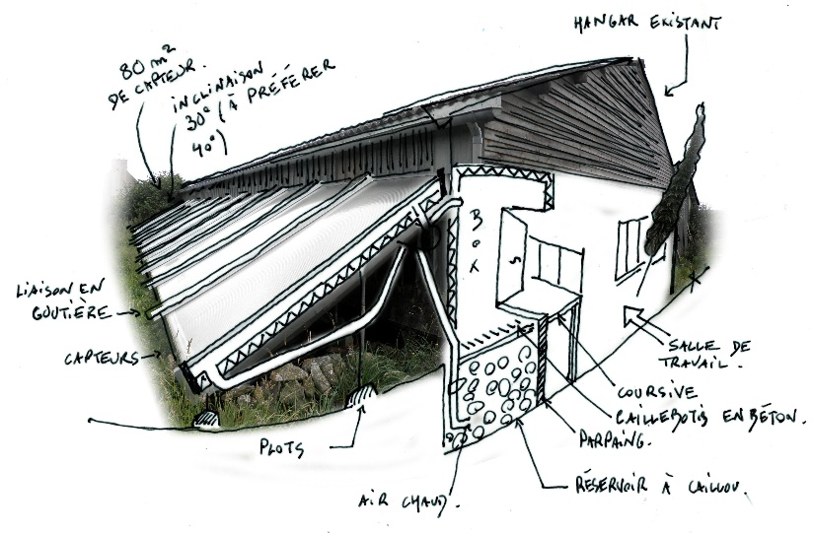
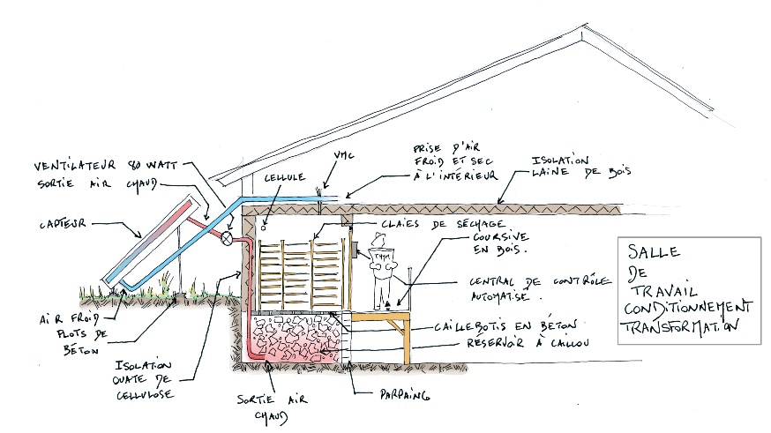
- Inox
- Wood:

- Plastic
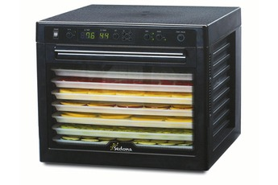

- Trays
- Fabric

- Screen
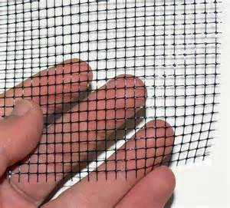

- Heat source
    - Solar
- Direct:
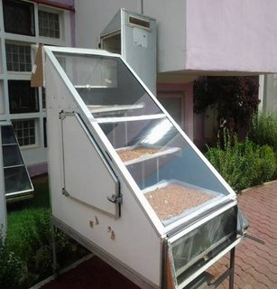
- Indirect:
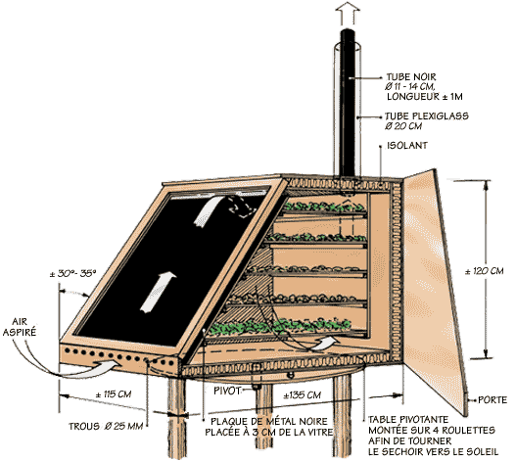
    - Electrical (resistor)
    - 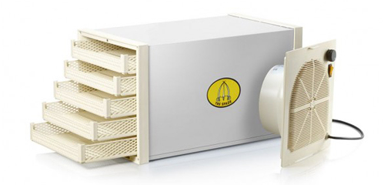

    - Warm and pollute flow

- Convection
    - Kind
- Natural
Work with rising warm airflow
- Forced
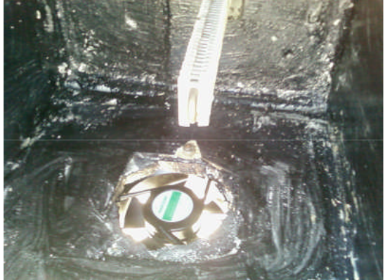
    - Direction
- Perpendicular to the trays
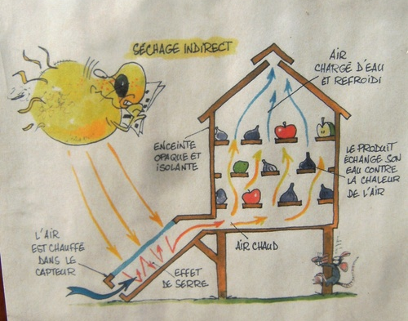
- Parallel to the trays
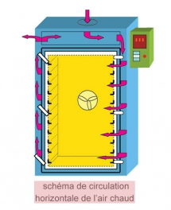

- Alimentary legislation
Contact alimentaire direct
- claie

Contact alimentaire indirect
Tout les composants d’entré

